3.3 犯罪相关性综合分析 (Comprehensive Correlation Analysis)
为了深入探究不同犯罪变量之间的依赖关系，我们从多变量线性关系、时间维度特异性以及执法效率差异三个维度进行了分层分析。

1. 宏观依赖性：多变量相关性矩阵 (The Macro View: Correlation Matrix)
首先，我们构建了关键特征的相关性矩阵（见 Figure 1）。虽然由于犯罪数据的类别属性（Categorical Nature），整体皮尔逊相关系数较低，但我们仍发现了两个关键的结构性关联：
- 犯罪类型决定逮捕率 (Type-Driven Arrests): Arrest_Flag 与 Type_Code 呈现出全局最强的正相关性 (0.20)。这表明“能否抓到嫌疑人”主要不取决于时间或地点，而取决于犯罪的性质（例如毒品犯罪易抓捕，盗窃案难抓捕）。
- 家庭纠纷的独立性 (Distinct Nature of Domestic Crimes): Domestic_Flag 与 Type_Code 呈显著负相关 (-0.21)。这揭示了家庭纠纷案件集中在特定的少数犯罪类型中，与公共街头犯罪的模式截然不同。
- 非线性的时间关系: Hour 与其他变量的线性相关性接近于 0。这并不代表时间不重要，而是暗示了时间与犯罪之间存在复杂的非线性关系（如波峰波谷），需要通过后续的热力图进一步通过可视化验证。

2. 微观时序特征：归一化时间热力图 (The Micro View: Temporal Specificity)
为了解开相关性矩阵中隐藏的时间规律，我们绘制了归一化时间热力图（见 Figure 2）。分析揭示了不同犯罪类型具有极强的**“作息时间” (Temporal Profiles)**：
- 欺诈案的“办公时间”效应: DECEPTIVE PRACTICE 在 09:00, 12:00, 00:00 出现极高的时间尖峰，这与商业交易时间及系统自动报告周期高度吻合。
- 毒品犯罪的“双峰模式”: NARCOTICS 呈现出清晰的双峰分布，活跃高峰集中在 10:00-11:00 和 19:00-20:00，这为特定时段的警力部署提供了直接依据。
- 暴力与财产犯罪的错位: 数据验证了经典的犯罪学模式——BURGLARY（入室盗窃）高发于工作时间 (08:00-15:00，趁家中无人)，而 ROBBERY（抢劫）则随着夜幕降临 (18:00-23:00) 而激增。

3. 业务洞察：执法效率差距分析 (Business Insight: Efficiency Gap)
最后，我们扩展分析了 Top 15 犯罪类型的逮捕率（见 Figure 3），揭示了当前警务模式面临的严峻挑战——“主动与被动执法的两极分化”：
- 主动执法的高效性 (Proactive Policing): 毒品 (NARCOTICS, ~99%) 和武器违规 (WEAPONS VIOLATION, ~65%) 的逮捕率极高。这类犯罪通常由警察主动发现（如交通拦截、搜身），因此“发现即逮捕”。
- 被动响应的痛点 (The Reactive Gap): 相比之下，财产类犯罪如入室盗窃 (BURGLARY) 和机动车盗窃 (MOTOR VEHICLE THEFT) 的逮捕率呈断崖式下跌，均低于 20% 的效率红线（部分甚至低于 5%）。这类犯罪通常在发生后才被报告，警察处于被动响应状态。

总结论 (Conclusion for Phase 1)
综上所述，EDA 分析表明：虽然简单的线性模型难以捕捉犯罪规律，但犯罪类型 (Primary Type) 和 小时 (Hour)包含着极强的预测信号。
特别是针对逮捕率极低的财产类犯罪（盗窃、入侵），传统的“事后响应”模式已经失效。这证明了本项目开发预测性警务模型的必要性——只有通过算法提前预测高风险时空区域，将警务模式从“被动调查”转变为“主动威慑”，才能有效填补这一巨大的治安效率缺口。

2. Data Preprocessing and Feature Transformation
To ensure data quality and analytical consistency across the project, we implemented a rigorous two-stage data processing pipeline. First, we applied a comprehensive cleaning strategy to the raw Chicago Crime Dataset. We filtered the dataset to retain records from 2015 to 2024, strictly adhering to the project requirement of using the last 10 years for model development while reserving 2025 data for future testing. We systematically removed records lacking geographical coordinates (Latitude and Longitude) or valid location descriptions, as these fields are prerequisites for spatial hotspot identification. Furthermore, we parsed the raw timestamp strings into granular temporal features—including Hour, Month, and DayOfWeek—to enable precise cyclical analysis. To reduce dimensionality and noise, we aggregated the hundreds of sparse Location Description tags into the top 20 categories, grouping the remainder as "OTHER," which significantly improved the stability of subsequent statistical aggregation.
Following the general cleaning, specific feature transformations were engineered to facilitate the correlation analysis. Since the Pearson correlation coefficient requires numerical input, we applied Label Encoding to categorical variables, converting Primary Type and Location Group into numerical codes (Type_Code and Location_Code). This transformation allowed us to quantify the linear dependencies between categorical attributes and the arrest outcome. Additionally, for the temporal heatmap analysis, we employed row-wise normalization on the crime-frequency matrix. Instead of using raw counts, which would be dominated by high-volume crimes like theft, we calculated the probability distribution of each crime type across the 24-hour cycle. This critical step standardized the data scale, revealing distinct temporal patterns—such as the late-night prevalence of robbery versus the daytime occurrence of deceptive practice—that would otherwise be obscured by volume disparities.

3.3 Comprehensive Correlation Analysis
To investigate the underlying dependencies between crime variables, we performed a stratified analysis across three dimensions: multivariate linear correlations, temporal specificities, and enforcement efficiency disparities.

1. The Macro View: Multivariate Correlation Matrix

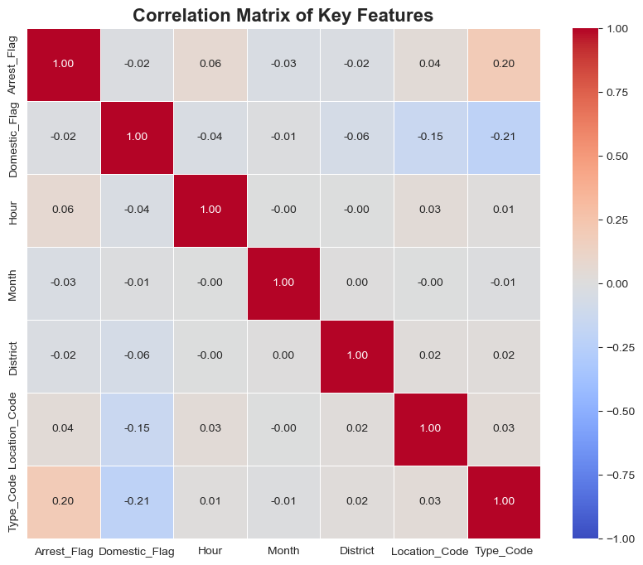

Figure 1
First, we constructed a correlation matrix of key features (see Figure 1). Although the overall Pearson correlation coefficients were low due to the categorical nature of the data, we identified two critical structural associations:
- Type-Driven Arrests: Arrest_Flag showed the strongest positive global correlation with Type_Code (0.20). This indicates that the likelihood of apprehension depends primarily on the nature of the offense (e.g., narcotics vs. theft) rather than time or location.
- Distinct Nature of Domestic Crimes: Domestic_Flag displayed a significant negative correlation with Type_Code(-0.21). This reveals that domestic incidents are concentrated within specific crime categories and differ distinctly from public street crime patterns.
- Non-linear Temporal Relationships: The near-zero linear correlation between Hour and other variables does notimply insignificance. Instead, it suggests complex non-linear relationships (e.g., cyclical peaks), requiring further validation through heatmaps.

2. The Micro View: Temporal Specificity
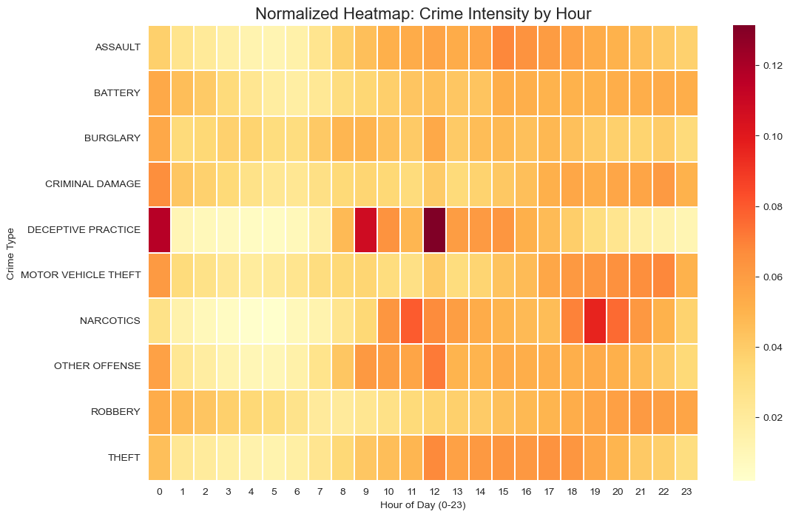
Figure 2
To decode the temporal patterns hidden in the correlation matrix, we generated a Normalized Temporal Heatmap (see Figure 2). The analysis revealed strong temporal profiles for different crime types:
- "Business Hour" Effect in Deceptive Practice: DECEPTIVE PRACTICE shows sharp spikes at 09:00, 12:00, and 00:00, aligning with business transaction hours and automated system reporting cycles.
- "Two-Peak" Pattern in Narcotics: NARCOTICS exhibits a clear bimodal distribution with activity peaks at 10:00–11:00 and 19:00–20:00, providing direct evidence for targeted shift scheduling.
- Divergence between Violence and Property: The data validates classic criminological patterns—BURGLARYpeaks during work hours (08:00–15:00, when homes are empty), while ROBBERY escalates during evening hours (18:00–23:00).

3. Business Insight: The Enforcement Efficiency Gap

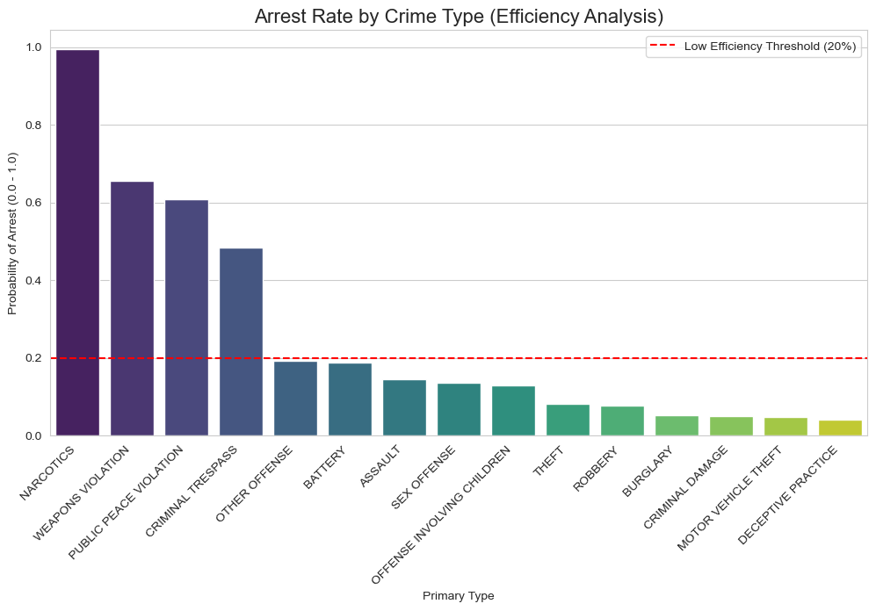

Figure 3
Finally, we analyzed the arrest rates for the Top 15 crime types (see Figure 3), revealing a stark dichotomy between proactive and reactive policing:
- High Efficiency in Proactive Policing: Crimes like NARCOTICS (~99%) and WEAPONS VIOLATION (~65%) show exceptionally high arrest rates. These are typically "proactive" offenses where police initiation leads to immediate arrest.
- The Reactive Gap: In contrast, property crimes such as BURGLARY and MOTOR VEHICLE THEFT show a drastic drop in arrest rates, falling well below the 20% efficiency threshold (some even below 5%). These crimes are typically reported post-incident, placing police in a reactive stance.

Conclusion
In summary, the EDA demonstrates that while simple linear models fail to capture complex crime dynamics, Primary Type and Hour contain strong predictive signals.
Specifically for low-clearance property crimes (e.g., Theft, Burglary), traditional "reactive" methods are insufficient. This justifies the necessity of developing a Predictive Policing Model in this project—only by algorithmically forecasting high-risk spatiotemporal zones can we shift operations from "reactive investigation" to "proactive deterrence," effectively closing this efficiency gap.

